Name of Employee:
Account Information
 | Bank #1 Account Information |  |  |  | Bank #2 Account Information
Bank Name
Type of Account |  | Checking |  | Savings |  | Checking |  | Savings
9-Digit Routing #
Account Number
Deposit Direction |  | Deposit entire paycheck |  |  |  | Deposit entire paycheck
Deposit Direction |  | Deposit partial $ amount $ |  |  |  | Deposit partial $ amount $
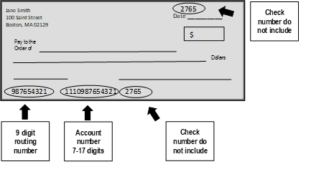
EXAMPLE
Authorization Agreement
I hereby authorize automatic deposits to my account(s) at the financial institution(s) named above. I also authorize
 |  | Payroll provider to make withdrawals from this account if a credit entry is made
in error. Further, I agree not to hold |  |  |  |  | payroll provider or
responsible for any delay or loss of funds due to incorrect or incomplete information supplied by me or by my financial institution or due to an error on the part of my financial institution in depositing funds to my account. In addition, I understand that it may take up to two weeks for this initial direct deposit to take effect. This agreement payroll provider receives a written notice of cancellation from me or my financial
will remain in effect until |  |  |  | payroll provider receives a written notice of cancellation from me
or my financial institution, or until I submit a new direct deposit form to
Signature
Employee Signature: |  | Date:
IMPORTANT NOTE: For a checking account, please attach a voided check with this form. For a savings account, please attach a document from your bank indicating the routing number and account number (e.g., portion of your bank statement showing the routing and account numbers).

